Pokhara University

Level: Bachelor | Semester – Fall | Year : 2009
Programme: BE |  | Full Marks : 100
Course: Control System |  | Time : 3hrs.

Candidates are required to give their answers in their own words as far as practicable.
The figures in the margin indicate full marks.

Attempt all the questions.

1. | - Obtain the transfer function of the systems shown in following figures (a) and (b).  - Obtain the transfer function for the block diagram shown below using block diagram reduction technique. | 8  7
2. | - The open loop transfer function of a unity feedback system is given by 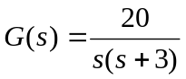  - Calculate the natural frequency of the oscillation and damping ratio.  - Calculate maximum overshoot for a unit step input and the peak time.  - A unity feedback control system has the forward transfer function. | 7  8
3. | - Sketch the root loci for the system shown in following figure. (The gain K is assumed to be positive.)  - What do you understand by the terms negative feedback and positive feedback used in control system engineering? Discuss their relative merits and demerits. | 10  5
4. | - Find out the condition for the stability of the system whose characteristics equation is given as: S⁴+20S³+224S²+1240S+2400+K=0 by R-H criterion. Determine the value of K which will cause sustained oscillations. Find the frequency of oscillations.  - Draw the plot of G(j)superimposed on Nicholas chart for the unity feedback system whose open loop transfer function is 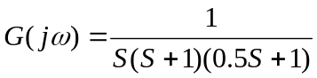. For the plot determine the phase margin, gain margin, resonant frequency and bandwidth.  OR  - Sketch the polar plot for G(s) = 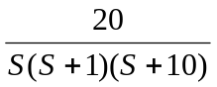and determine gain margin, phase margin and stability of the system with the unity feedback. | 7  8
5. | - Construct the bode plot for a unity feedback control system having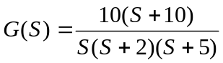.  - For the following circuit, determine its State Space representation model. | 10  5
6. | The forward path transfer function of a control system is given by 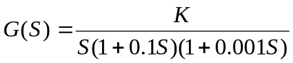. Design a suitable lead compensator having the phase margin 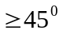. Velocity Constant Kv = 1000 sec⁻¹. | 15
7. | Write short notes on (Any Two)  - Open loop and Close loop System  - PID Controller  - Frequency response specifications | 5×2

